Optimize your cover letter to get more job interviews

This free cover letter template will help you write an ATS-friendly cover letter. But how do you know what the hiring manager is looking for? What skills and experience should you include to show you’re the best candidate?

Jobscan’s cover letter checker helps you optimize your cover letter for each job listing so that your application is more attractive to recruiters and hiring managers.

An optimized cover letter leads to more responses, more interviews, and more offers for the jobs you really want.

“Honestly, it was like the floodgates opened. Within a week…I was absolutely flooded with contacts and people reaching out.” Kelly, South Carolina, Jobscan User

”It’s the greatest tool that I have seen when it comes to searching for jobs.” Mark Stark, Career Success Coach

“We’re seeing easily 30% or more increase in calls from recruiters when our students use Jobscan to tailor their resumes.” Jeffrey Stubbs, Director, Baylor University Career Center

It’s frustrating to apply for dozens of jobs and not get any interviews. Use Jobscan to optimize your resume, cover letter, and LinkedIn profile.

90% of Jobscan Premium users landed an interview.

Jobscan users have been hired by:

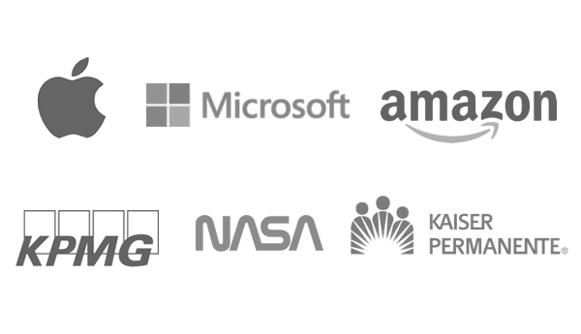



- BENJAMIN HENDERSON -
Career Coach/Resume Writer

Orlando, FL • (555) 555-1234 • benhenderson@email.com • linkedin.com/in/benjamin-henderson

October 7, 2022
Jenny Johnson
Human Resources
IHeartjobs
55 Bixby Way
Manchester, NH 40344

Dear Jenny,

I hope all is well! As I mentioned in our LinkedIn chat, I’d love to hear your perspective on the industry and career opportunities.

As you know from our time together at ResumesRock, I love client-facing positions and anything that allows me to directly help job seekers. Lately, I’ve been helping over 250,000 job seekers optimize their resumes here at Jobscan.

I’m currently looking for a new career venture helping job seekers one-on-one and would love to hear your take! Would you like to meet for coffee or have a short Zoom meeting soon?

Hope to hear from you soon,

Benjamin Henderson

