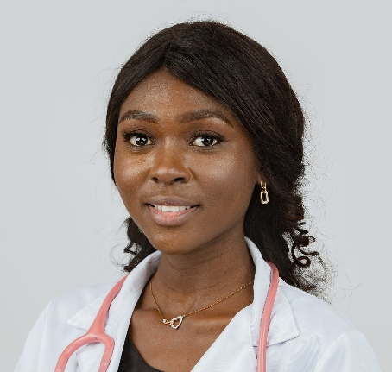

Dr. Natasha Wren, DVM
Address: 4 Elm St., Dallas, TX 75001
Phone: 222 555 7777
Email: natasha@email.com

Objective
To leverage my extensive clinical experience, strong surgical skills, and passion for veterinary medicine in a leading veterinary hospital or clinic in Dallas, Texas, where I can contribute to providing excellent animal care and further enhance my professional skills.

Education

- Doctor of Veterinary Medicine (DVM)
University of Texas at Dallas, College of Veterinary Medicine
Dallas, TX
Graduated: May 2050

- Bachelor of Science in Animal Biology
Texas State University
San Marcos, TX
Graduated: May 2046

Licensure and Certifications

- Licensed Veterinarian, State of Texas (2050 - Present)
- Certified in Advanced Veterinary Cardiology (2052)
- Member of the American Veterinary Medical Association (AVMA)

Professional Experience

- Veterinarian
Dallas Animal Wellness Clinic
Dallas, TX
June 2052 - Present
  - Led a team of veterinary technicians to provide healthcare to over 3,000 animals annually.
  - Conducted regular wellness exams, vaccinations, and preventative care.
  - Performed surgical procedures, including spaying/neutering, orthopedic surgeries, and emergency surgeries.
  - Collaborated with specialists for cases requiring advanced medical attention.

- Veterinary Surgeon
Metro Dallas Veterinary Hospital
Dallas, TX
January 2051 - May 2052
  - Oversaw the surgical unit, performing an average of 5 surgeries daily.
  - Specialized in soft tissue surgery, ensuring quick recovery times for the animals.
  - Trained junior veterinarians in surgical techniques and safe anesthetic practices.
  - Managed post-operative care, including wound management and pain relief strategies.
- Veterinary Associate
Paws & Whiskers Animal Clinic
Dallas, TX
July 2050 - December 2050
  - Worked closely with senior veterinarians to diagnose and treat a wide range of medical conditions in animals.
  - Built rapport with pet owners, educating them on preventive care and pet nutrition.
  - Handled routine check-ups, vaccinations, and minor surgical procedures.
  - Contributed to the clinic's initiative of community outreach, conducting free animal health camps monthly.

- Veterinary Intern
Lone Star Veterinary Hospital
Dallas, TX
June 2049 - May 2050
  - Assisted senior veterinarians in surgeries and diagnostic procedures.
  - Developed skills in radiology, ultrasound, and blood work interpretation.
  - Provided emergency care and participated in on-call rotations.

Continuing Education

- "Advanced Dental Care in Small Animals" Workshop, Dallas Veterinary Association, 2052
- "Veterinary Oncology: New Advances and Treatments" Seminar, AVMA Conference, 2051
Publications

- Wren, N., & Smith, J. (2053). "Innovative Treatment Protocols for Canine Parvovirus: A Review." Veterinary Quarterly, 54(1), 12-19.

- Martinez, A., Wren, N., & Lee, T. (2053). "Endocrine Disorders in Aging Dogs: Diagnosis and Management." Veterinary Journal of Medicine, 40(4), 320-328.

- Wren, N., & Patel, S. (2052). "Therapeutic Approaches to Feline Hyperthyroidism." Journal of Cat Medicine & Surgery, 22(6), 455-461.

- Wren, N., & Smith, J. (2051). "Emerging Pathogens in Domestic Felines: A Case Study from Dallas." Journal of Veterinary Research, 32(3), 145-150.

- Jackson, L., Wren, N., & Lopez, M. (2051). "The Role of Diet in Dermatological Conditions of Domestic Canines." Journal of Canine Clinical Nutrition, 17(2), 78-85.

- Wren, N., Thompson, R., & Lee, M. (2050). "Heartworm Disease in Texan Dogs: Recent Trends and Prevention." Journal of Parasitology & Veterinary Medicine, 28(5), 399-405.

- Wren, N., & Davis, P. (2050). "Neurological Manifestations of Tick-Borne Diseases in North American Pets." Veterinary Neurology and Neurosurgery Journal, 26(1), 5-12.

- Gonzalez, F., Wren, N., & Walker, B. (2049). "Comparative Study on Behavioral Changes in Spayed and Non-Spayed Female Cats." Journal of Feline Behavior, 13(4), 215-220.

- Wren, N., & Hughes, L. (2049). "The Efficacy of Probiotics in Gastrointestinal Health of Senior Dogs." Veterinary Digest, 45(7), 320-326.

- Wren, N., O'Brien, S., & Turner, W. (2048). "The Impact of Urbanization on Wild Animal Injuries: A Decade Review." Journal of Wildlife Rehabilitation, 41(3), 105-113.

Professional Memberships

- American Veterinary Medical Association (AVMA), Member (2050 - Present)
- Texas Veterinary Medical Association, Member (2050 - Present)
- Dallas Veterinary Society, Member (2051 - Present)
- Association for Veterinary Orthopedic Surgeons, Member (2051 - Present)
- International Association of Feline Practitioners (IAFP), Member (2052 - Present)
- Society for Veterinary Emergency and Critical Care, Member (2052 - Present)
- American Association of Veterinary Radiology, Member (2053 - Present)

Awards and Honors

- "Best Young Veterinarian" by Dallas Veterinary Association, 2052
- Academic Excellence Award, University of Texas at Dallas, College of Veterinary Medicine, 2050
- "Outstanding Surgical Skills Award", Association for Veterinary Orthopedic Surgeons, 2053
- "Veterinary Researcher of the Year", American Veterinary Medical Association (AVMA), 2053
- "Community Engagement Award", Texas Veterinary Medical Association, 2051
- "Distinguished Alumni Award", Texas State University, 2052
- "Excellence in Feline Care Award", International Association of Feline Practitioners (IAFP), 2052
- "Pioneering Research Award", Journal of Veterinary Research, 2053
- "Veterinary Educator of the Year", Dallas Veterinary Society, 2054

Skills

- Proficient in small animal surgery, including orthopedic procedures
- Expertise in diagnostic tools such as X-ray and ultrasound imaging
- Strong patient management and communication skills

