Optimize your cover letter to get more job interviews

This free cover letter template will help you write an ATS-friendly cover letter. But how do you know what the hiring manager is looking for? What skills and experience should you include to show you’re the best candidate?

Jobscan’s cover letter checker helps you optimize your cover letter for each job listing so that your application is more attractive to recruiters and hiring managers.

An optimized cover letter leads to more responses, more interviews, and more offers for the jobs you really want.

“Honestly, it was like the floodgates opened. Within a week…I was absolutely flooded with contacts and people reaching out.” Kelly, South Carolina, Jobscan User

”It’s the greatest tool that I have seen when it comes to searching for jobs.” Mark Stark, Career Success Coach

“We’re seeing easily 30% or more increase in calls from recruiters when our students use Jobscan to tailor their resumes.” Jeffrey Stubbs, Director, Baylor University Career Center

It’s frustrating to apply for dozens of jobs and not get any interviews. Use Jobscan to optimize your resume, cover letter, and LinkedIn profile.

90% of Jobscan Premium users landed an interview.

Jobscan users have been hired by:

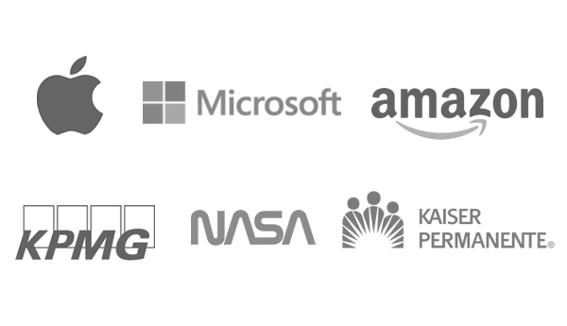

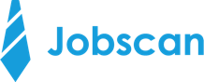

Cover Letter Template for a Creative Position
Once you’ve filled out the template, check to see how well it matches the job description using the Jobscan Cover Letter Scanner. (Don’t forget to delete this when using)

[Date]

[Your name]
[Street Address
City, State, Zip]
(123)-456-7890
email@mail.com
[Link to your portfolio or website]

[Recipient’s name]
[Title]
[Company name]
[Street Address
City, State, Zip]

Greeting
- Start with a formal greeting, such as “Dear Mr./Ms. Last Name”.
- If you can’t find the name of the hiring manager, you can use “Dear Hiring Manager” or “To Whom it May Concern”.

First Paragraph
- In one to three sentences, explain why you are writing and mention the specific position you are applying for.
- Briefly share your creative background and experience.
- If someone referred you, this is the place to mention it.
Example: “I'm excited to be applying for the Visual Artist position at Hansen and Lang. As an artist with extensive formal training and decades of experience working with multimedia projects, there is no doubt in my mind that I would excel in this role.”
Middle Paragraph(s)
- This is where you sell yourself to the hiring manager and show why you are the best candidate for the job.
- Share what inspires you in your artistic pursuits. How has that led you to apply for a job in this company specifically? Does the company’s mission statement and values reflect your own?
- Provide more detail about at least one project or achievement that you have outlined on your resume.
- Expand on any projects or freelance work you've completed that aren't as visible on your resume.
- As long as it is appropriate, feel free to discuss side projects that reveal how creativity flows through your life in a way that’s relevant to the job.
- Highlight your successes and confidently express how you can bring your creative passion to this new position.
Example: “In my last position at Royal Retail, I not only designed the new technology product from start to finish, but was also responsible for its marketing. This role gave me a well-rounded understanding of how products are made and sold, which in turn led to designs that were more effective and impactful. Consequently, product sales went up by 25%, surpassing company expectations; we even won a 2021 Package Innovation Award!”
“I've recently added video and animation to my portfolio, which are quickly becoming essential elements of digital marketing. I've also launched a popular YouTube series on producing videos for social media, which demonstrates both my design talents as well as my desire to continue learning. My YouTube channel has helped me stay up-to-date with the latest marketing trends while also allowing me to discover creative methods to create eye-catching visuals.”
Closing Paragraph
- Thank the reader for their time and attention.
- Reiterate your interest and enthusiasm about the new position.
- Add a link to your digital portfolio or website, even if you already have it in the header of the cover letter.
- Mention that you look forward to hearing from them shortly.
Example: “Thank you for considering my application. I strongly believe this position would be the perfect fit for my skills and talents as well as my desire to push artistic boundaries. My digital portfolio can be found at www.artattack.com. I look forward to hearing back from you at your earliest convenience.”

Thank You,
[Your full name]

