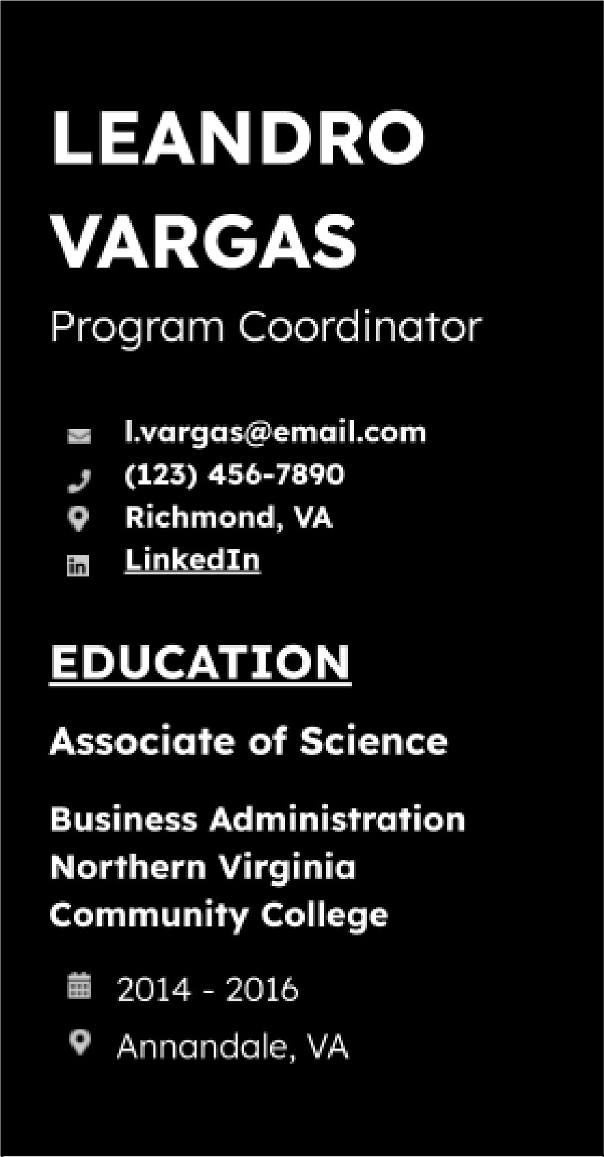
WORK EXPERIENCE
Need some more inspiration? Check out our resume examples for loads of relevant job description points to help.

SKILLS
- Trello

- Microsoft Excel

- Google Sheets

- Zoom

- Google Forms

- Dropbox
- Clockify

- Sprout Social

Program Coordinator
Virginia Department of Health - Richmond, VA
2020 - CURRENT
- Handled the scheduling and logistics for 14 health workshops by using Microsoft Excel to track the number of participants, cutting down administrative time by l.9 hours.
- Led a team of 7 members to develop a nutrition education program, which improved healthy eating habits among 36% of participants, as measured by program surveys.
- Integrated Clockify to monitor project timelines, reducing project delays by 22% and ensuring on-time delivery for health program initiatives.
- Created a healthy living campaign on social media for public health awareness, boosting mentions and shares by 47.3% through Sprout Social's strategic planning features.

Program Associate
Dominion Energy - Richmond, VA
2018 - 2020
- Reduced overhead costs by $527 through automating the reporting processes for energy conservation programs with Trello.
- Established a safety protocol campaign for field operations, resulting in a 46% decrease in reportable safety incidents in one year.
- Created Google Sheets reports that reduced manual entry time by 73%, allowing real-time updates on project budgets and expenditures.
- Formed a virtual Zoom office hours initiative to provide live support to program participants, lowering project delay incidents by 38% due to immediate clarifications.

Program Assistant
Carilion Clinic - Roanoke, VA
2016 - 2018
- Implemented a Dropbox file tagging system that saved an estimated 211 hours annually in search time.
- Developed an email management system that helped decrease
response time for patient inquiries by 23%.
- Facilitated the feedback collection process for 6 healthcare programs by using Google Forms, recording a 28% increase in patient satisfaction scores as measured by post-visit surveys.
- Managed the clinic's inventory for office and caregiving supplies, preventing any stock-outs incidents for critical items.

